## Hatch timing tool (M14)

To do

* Get AWS instance working on cesar account
  + <http://13.54.70.163:3838/RLEM-hatch-map/>
  + 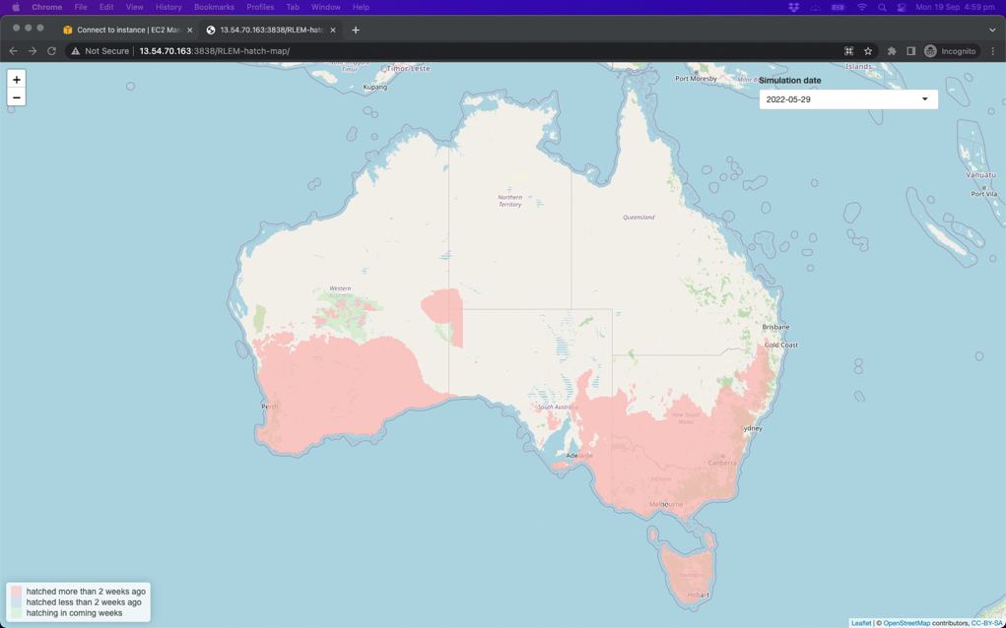
* Update final report

**Aims**

M14. Cesar. Develop regional RLEM hatch date grower tool to optimise monitoring for RLEM pressure at crop emergence. Validate this tool using early-season field collections that infer hatch date from the oldest life-stage observed.

**Brief methods**

We extended a previous study on predicting hatch dates from regional temperature and rainfall conditions [(McDonald et al. 2015)](https://paperpile.com/c/eiwucZ/wHCO) to an easy-to-use web interface that will provide the predicted hatch date for a user-defined location. This includes an option for real-time weather data for the current growing season, or long-term average conditions.

After completion of a draft interface, feedback from end-users was sought through a webinar and focus group at a GRDC grower network meeting. Facilitated by Belinda Cay, and using the Group Map elicitation software (Appendix 2), several questions were posed to the group to provide direction for future development of the tools so that it will best meet the needs of growers.

The new tool was also promoted through various communication channels including SARDI pestfacts and PestFacts south-eastern.

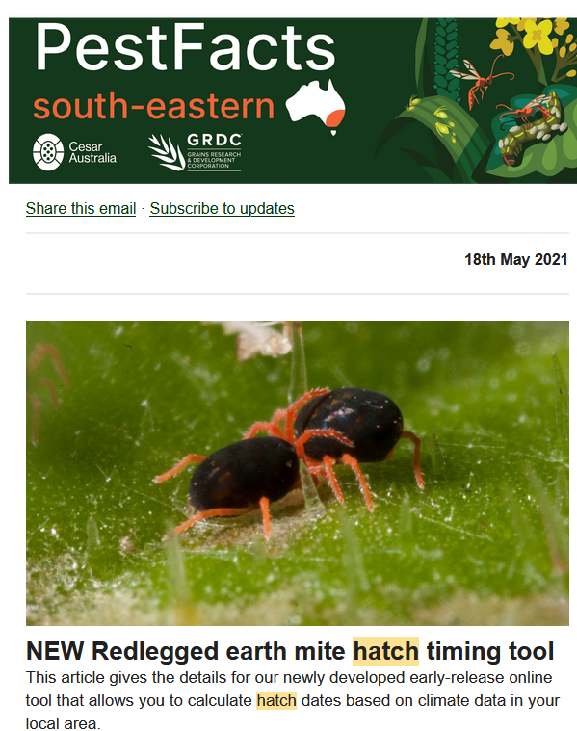

**Figure.** Example of RLEM hatch tool promotion in 2021.

To validate the predictions, in 2022, during the period of predicted mite hatching, we will sample along a transect running from north to south into higher rainfall zones in grain growing regions. Along this gradient, sample locations separated by ~50 km will have been predicted to be suitable or unsuitable for mite hatching (depending on rainfall and temperature conditions). At each sample point we will collect mites from suitable vegetation along roadsides adjacent to grain crops and pastures and assess the approximate life stages of ~100 mites each site where they have hatched. From the observed life stages and local climatic conditions we will be able to estimate the hatch date.

A second validation dataset will be obtained through calling agronomists at predicted hatch times to check whether or not they observed active mites the last time they were in the field. We will record the location, and date the observation was made. This process will also help to increase awareness of the tool among agronomists.

**Results and outcomes to date**

The interface is currently in draft form and can be found at the following link: <https://cesaraustralia.com/pestfacts/new-redlegged-earth-mite-hatch-timing-tool/>

To obtain a hatch prediction, first, the user selects their location of interest (see Figure 14.1 - where east of Horsham, Vic is selected).

**FIgure 14.1** Location selector for hatch prediction webtool allows users to easily select their location of interest.

Next, the tool then retrieves current climatic data for the season up to the present date. Once temperature and rainfall conditions for the current season have been met, the hatch date will be indicated on the graph that shows local rainfall and temperature conditions according to the SILO climatic database (Figure 14.2).

**Figure 14.2** Temperature and rainfall for the 2021 season in west Victoria are used to predict the hatch date for RLEM.

If temperature and rainfall conditions for hatching have not been met, users can access predicted hatch dates for their location across the last 25 years (Table 14.1).

**Table 14.1** Estimated date of hatch in west Victoria based on previous 25 years of climatic data. Chance of hatch represents the proportion of all years that were predicted to have hatched by the given date.

At the GRDC Grower Network meeting we presented the draft interface as part of a Tools and Tactics Discussion session. We asked the following questions and obtained the feedback from growers as summarised below.

1. Are we on the right track? Would an accurate forecast of hatch date help your monitoring and management activities?
2. Under what circumstances would you use such a tool?
3. Would you prefer such tools to be integrated with other digital ag services (e.g. Agworld, Back Paddock, Planfarm) or with grains management resources (e.g. GRDC website and/or Cesar PestNotes?)
4. What other improvements or considerations can you suggest to improve usefulness to growers?

The full feedback is available in Appendix 2. In summary, some users thought the tools would help target monitoring, particularly in high-risk situations, but there was a large appreciation of the role of prophylactic treatments (seed treatments, bare earth sprays, and tank mixes) that was seen as a barrier to monitoring based management approach. Other users called for more information on mite abundance at hatching (see Seasonal risk forecaster M13). In terms of interfaces, some users thought it might be more convenient to integrate with other digital ag platforms (e.g., AgWorld), while other users (particularly independent advisers) thought a standalone tool would be preferable. In any case, a timely reminder of the availability of such tools was seen to be useful (e.g., through seasonal industry updates). Integration of additional pests and linking to other resources and tools was suggested.

By the end of the GRDC investment we also hope to make forecast maps available to grain growers to help facilitate quick visualisation of regional conditions that can be easily shared through different means, including PestFacts or other industry extension outlets. Such a map has been mocked up for illustrative purpose (Figure 14.3).

**Figure 14.3** Mock up figure illustrating regional predictions of hatch likelihood based on the season’s climatic conditions.

**Next steps in 2022**

* Sample along a rainfall gradient during 2022 autumn and assess hatch status.
* Predictions will be validated through early season collection and agronomist reports (contacted at the predicted hatch date for their reason).
* Based on feedback, upgrades to the design and interface will be implemented.
* Single location point predictions will be extended to a mapped prediction for regional summaries

# 

# Appendix 2 - GroupMap feedback on draft RLEM hatch tool and seasonal risk forecaster tool

**Hatch tool feedback**

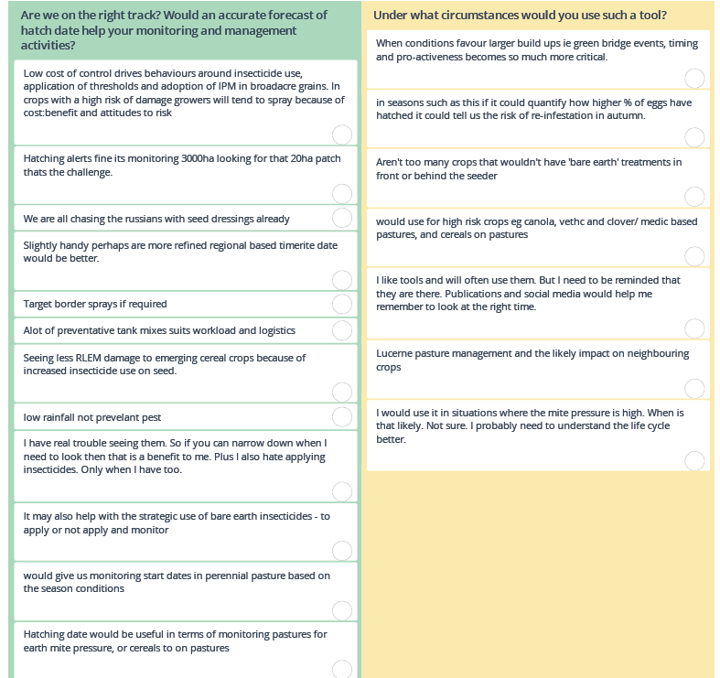

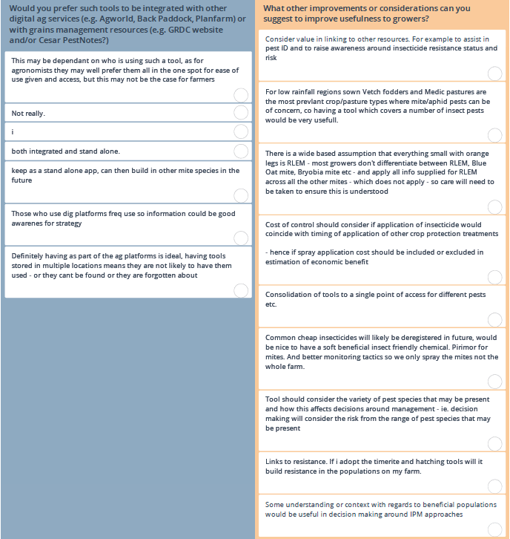

**Seasonal risk and cost-benefit tool feedback**

